**Deploying web application in docker container using Pipeline**

Create 2 ec2-instances with t2.micro

Jenkins server ip : 172.31.43.221

Application server ip : 172.31.39.162

Install git ,maven,docker in Jenkins server

Install docker in application server

Start the Jenkins service

Goto manage Jenkins 🡪 global tool configartion

Install git

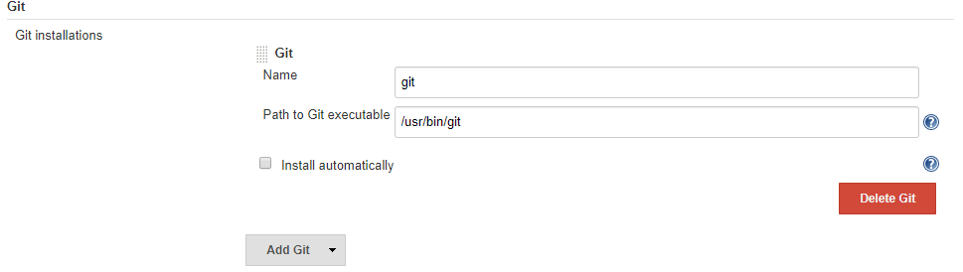

Install maven

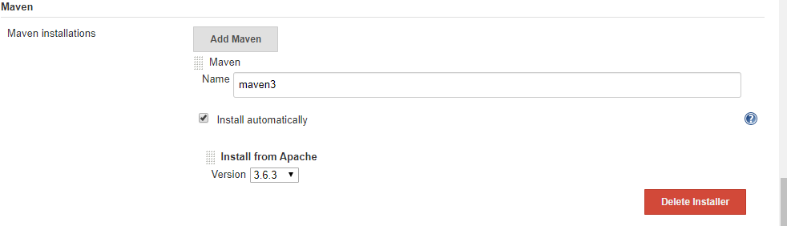

Install docker 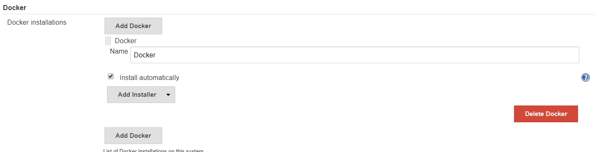

For git we have to follow like this

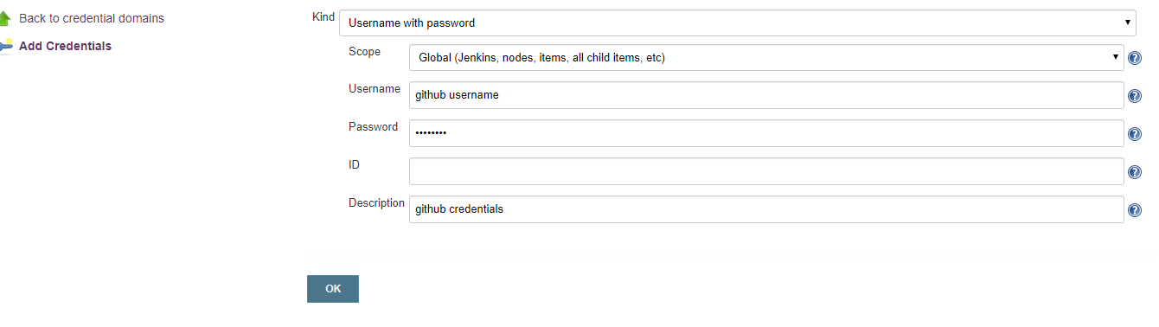

Here we no need to write full script .By default Jenkins is providing some sample pipeline scripts.

To work with that scripts just click on Pileline Syntax

Declaring docker hub credentials as a variables in pipeline syntax

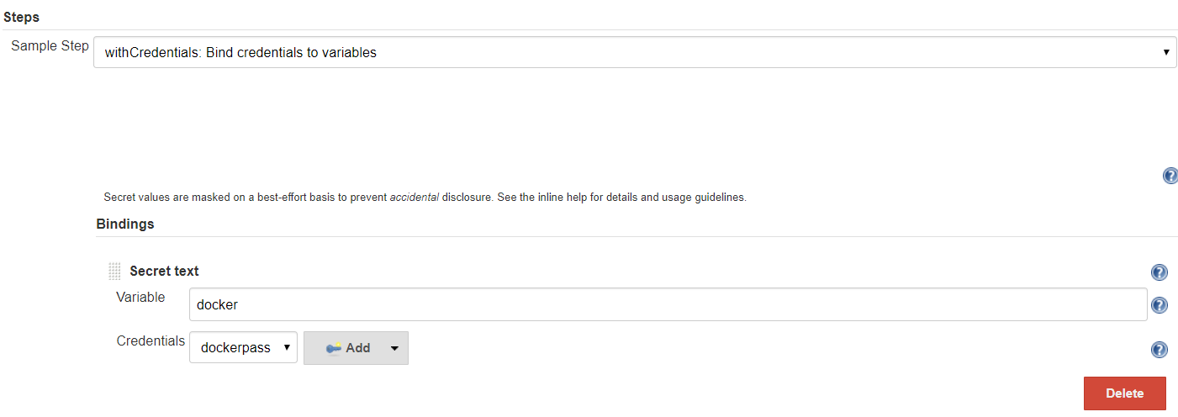

Configure the docker hub credentials as below

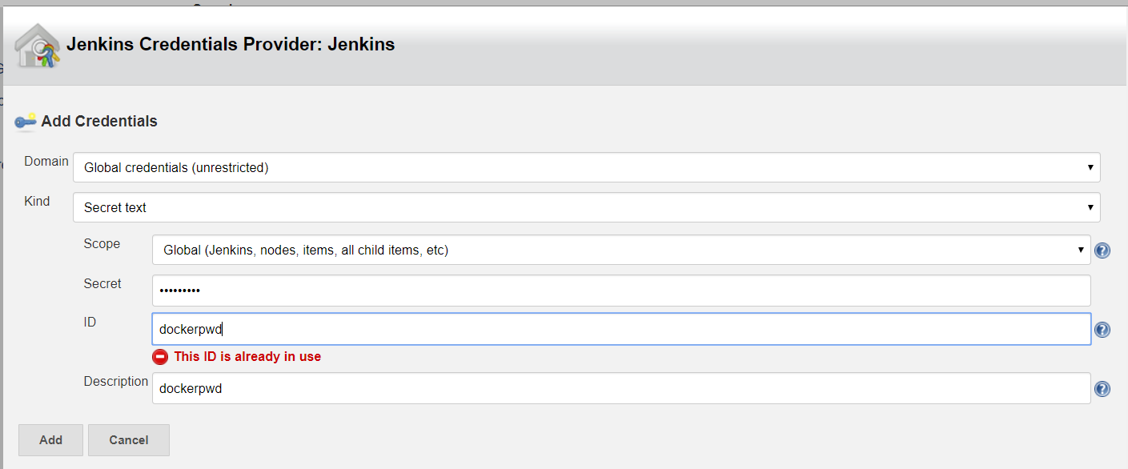

To run docker container in application-server

Install ssh agent plugin in Jenkins server

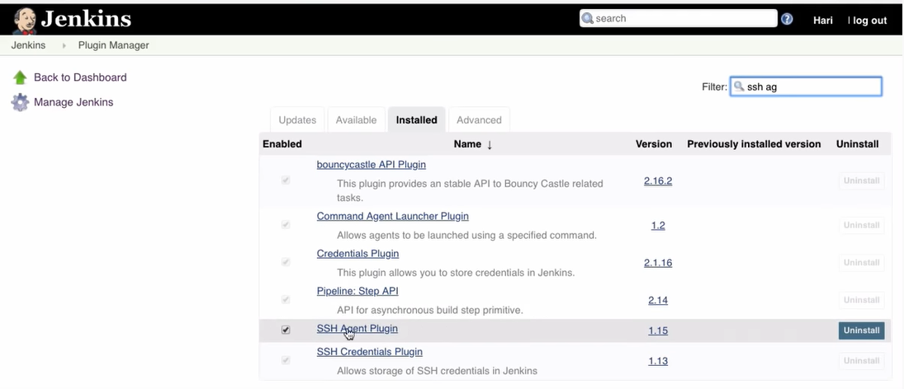

Select ssh gent in pipeline

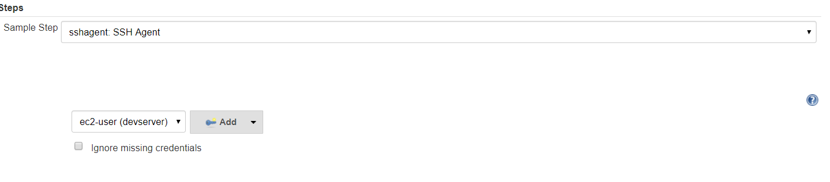

Add the credentials of application -server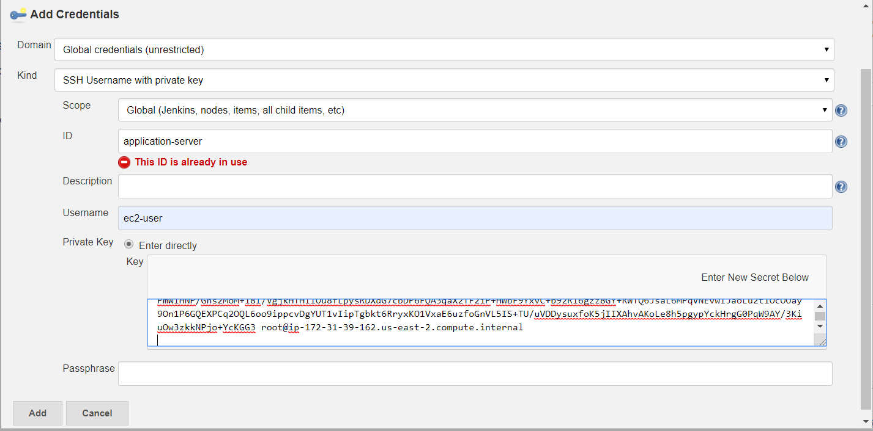

For ssh agent copy the keyfile from application server

ssh-keygen

copy the key from cat /root/.ssh/id_rsa.pub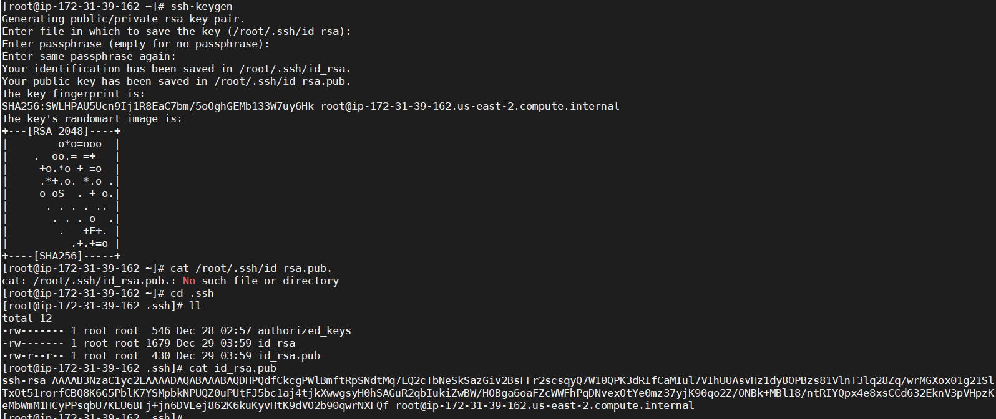

now go to Jenkins and create a new job for pipeline project

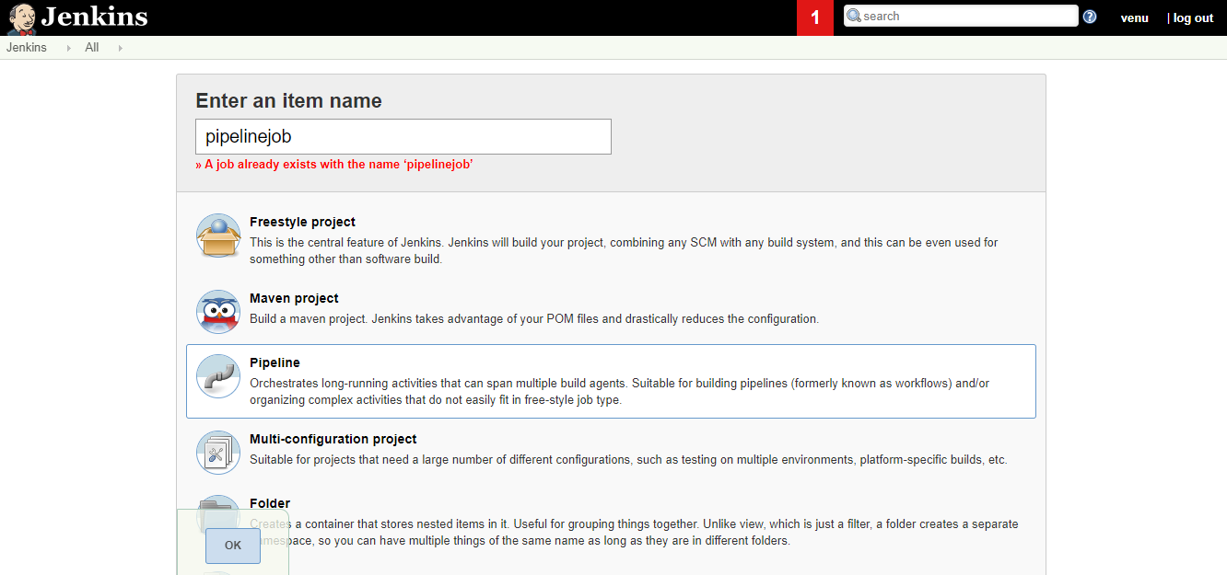

Write a pipeline script in pipeline tag

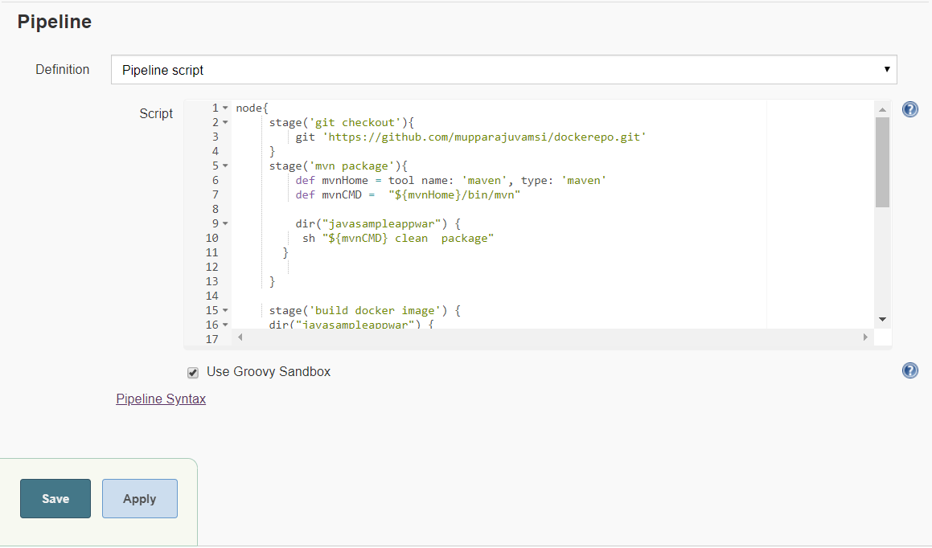

Now Build the Project

####################SCRIPT###################

*node{*

*stage('git checkout'){*

*git 'https://github.com/mupparajuvamsi/dockerepo.git'*

*}*

*stage('mvn package'){*

*def mvnHome = tool name: 'maven', type: 'maven'*

*def mvnCMD = "${mvnHome}/bin/mvn"*

*dir("javasampleappwar") {*

*sh "${mvnCMD} clean package"*

*}*

*}*

*stage('build docker image') {*

*dir("javasampleappwar") {*

*sh 'docker build -t mounika54/javasampleappwar .'*

*}*

*}*

*stage('push docker image'){*

*withCredentials([string(credentialsId: 'dockerpass', variable: 'dockerhub')]) {*

*sh 'docker login -u mounika54 -p ${dockerhub}'*

*}*

*sh 'docker push mounika54/javasampleappwar'*

*}*

*stage('working on devserver'){*

*def dockerrun = 'docker run -p 8080:8080 -d --name javasampleappwar1 mounika54/javasampleappwar'*

*sshagent(['devserver']) {*

*sh "ssh -o StrictHostKeyChecking=no ec2-user@172.31.39.162 ${dockerrun}"*

*}*

*}*

*}*